FRANCIS CARL WILLMOTT: Bad Eilsen, 8.4.1945

Some years ago a German historian, Ralf-Markus Lehmann, published an article (http://www.hiergeblieben.de/pages/textanzeige.php?limit=10&order=datum&richtung=DESC&z=1&id=29163) later incorporated in a book, about the capture of the Focke-Wulf design headquarters in Bad Eilsen on Sunday 8th April 1945, and the detention of chief design engineer, Professor Kurt Tank. He described, perhaps not wholly accurately, the significant role that Dad, then a Royal Signals officer, played in what was designated ‘Operation Woolworth’.

I discover that Lehmann has now made available further material which, leading on to other sources, greatly adds to our knowledge of the tactical context in which ‘Operation Woolworth’ took place.

As a reminder of information previously to hand, here is Dad’s own account of the action (1996), supplemented with two published excerpts, and the medal citation of the operation’s commander:

“We learned that American troops were advancing fast and that they were by-passing the two areas that would be occupied by the R.A.F. as their German Headquarters. The main site would be at the small spa town of Bad Eilsen, with a reserve station at Bückeburg. We were told that the Germans had retreated well beyond these places and so, with caution, it should be possible for the British to take over.
So it was that the Camp Commandant of the 2nd T.A.F., with a platoon of the R.A.F. Regiment, set out to take over Bad Eilsen. I went along with my Section Sergeant and batman to take charge of the telephone exchange. We had a German-speaking Polish Officer to act as interpreter.
The R.A.F. Regiment had been issued with a new but primitive-looking machine-gun as a personal weapon, the Sten gun. It was made entirely of metal and was an ungainly looking piece of ironmongery. My Section Sergeant, Cameron and my Driver/Batman, Read also took delivery of these unwelcome firearms. Sergeant Cameron had even had the chance of going to the range and learning to fire one. Accustomed to the elegant Lee-Enfield rifle he was contemptuous of this implement, but it took up much less room in our jeep.
The first part of our journey through Holland was over familiar territory and was completely without incident. The countryside in Germany was equally peaceful and we enjoyed the journey through the Pied-Piper country of Hamelin.
As we went on through hunting territory it wasn’t surprising to see farmers with deerstalker hats and rifles; until we saw they were wearing swastika arm-bands: these were Hitler’s “Dad’s Army”.
As we looked back we could see that these men had gathered together in the road behind us. We carried on until we were well out of their sight and then we halted for a conference.
At this point our Polish Flight-Lieutenant, by common consent, really took command. Stens were cocked at the ready. Our jeep brought up the rear with Sergeant Cameron leaning over the back to cover the road in our rear. The order was that there was to be no firing, except in response. In the event of being confronted we would put on speed and drive straight at the opposition. Our Polish colleague said that we should keep up this strategy right up to the point of entry to the Bad Eilsen Headquarters of the Focke-Wulf aircraft company.
This was the planning centre of the Luftwaffe source of supply. They had chosen this site because they thought it would be safe from Allied bombing. In this they were quite right; the R.A.F. had decided that they would preserve this site as an ideal centre for their own purposes.
As we approached the gates at great speed two guards in German grey uniform wandered into the road, but had no time to challenge and quickly jumped out of danger. They were disarmed by our first jeep-load and all their colleagues were similarly overwhelmed. I rushed out with the other two officers and entered the building unchallenged. At the top of a short flight of stairs we entered a large conference room where a board meeting was in progress. The Chairman stood up and came to meet us saying, in perfect English,
“Good afternoon, Gentlemen. We have been expecting you for some time.”
Before our Group Captain could respond our Polish interpreter took charge. The Chairman and all his board members were made to stand with their faces to the wall and their hands above their heads. By this time some of the R.A.F. platoon had entered and stood guard over the Germans. At a signal from our Polish friend, Sergeant Cameron and I went off in search of the Telephone Exchange. We had been given to understand that this was in the basement and we only had to go straight down another flight of steps.
This was indeed a large installation. There were some four or five men in charge. Unlike the soldiers outside they were dressed in magnificent blue uniforms with red facings and many shining buttons. The foreman, or officer, had a high peaked cap with a badge consisting of the German eagle and a swastika.
Amidst the sound of relays clicking and other mechanical noises our entry was not at first noticed. As soon as we were spotted the leader barked out an order and the others started running to the rear of the room where axes, sledge hammers and other destructive tools were stacked. We had been warned to expect this move, so both Sergeant Cameron and I barked out an impressive, “Halt!”
By itself this command might not have been decisive, but the Sergeant’s Sten was cocked ready, and the action of aiming, stamping and shouting discharged a burst of machine-gun fire. Sergeant Cameron swears that he never pressed the trigger but, as a practised old soldier, he had aimed his warning fire just over the head of the German leader. This “accidental” shot was completely effective and they all stopped and put up their hands in surrender. By a remarkable chance the beautiful peaked cap had been knocked off and a bullet had gone right through the badge.
The sound of shots had brought some of the R.A.F. soldiers down the stairs, so the prisoners were quickly secured. Later the German Chairman was brought to the switch-board and made to broadcast a message to all sub-stations forbidding the destruction of equipment and ordering obedience to the Allied Forces. The Polish Officer also spoke over all lines and there was complete obedience. They must have realised that they had no choice.
This realisation had not come to the German Home Guard that we had passed on our way. During the night there was a terrific explosion and we learned that the bridge over the Weser [it has not been possible to establish which bridge this was] had been blown up.
We were able to use our newly acquired telephone lines to contact Command Headquarters who sent a detachment of Royal Engineers. They repaired the bridge within 24 hours and mounted a guard there. We learned that tidal movements in the river had moved the explosives so that the damage had not been complete. Within days reinforcements for our own personnel were with us in Bad Eilsen.
Our Polish Officer made all the townsfolk assemble every evening and made them look at pictures of German atrocities in prison camps that were in process of being freed. I saw him knock down one man who had uttered words of disbelief.
Some time later the Polish Officer was awarded the British D.S.O. for playing the main part in this take-over. Sergeant Cameron, who had completed more than twenty years of loyal regular service, was awarded the D.C.M. The Camp Commandant and I were “mentioned in despatches” for being there and sent little oak leaves to wear on the campaign medal. We were awarded honorary ranks of Group Captain and Captain for the rest of our lives.”

Vincent Orange: ‘Coningham: A Biography of Air Marshal Sir Arthur Coningham’, 1990.

“Coningham sent forward a reconnaissance party, protected by a detachment of the R.A.F. Regiment, to occupy and prepare the permanent location of his headquarters in one of Germany’s most beautiful places: Bad Eilsen, near Bückeburg, in the province of Schaumberg-Lippe. It lay in an area allotted to Bradley’s Army Group, but the Americans permitted Coningham’s men to capture it, together with the design staff, drawing-office and a large quantity of valuable documents belonging to the Focke-Wulf aircraft firm which had been evacuated to Bad Eilsen from Bremen in 1942.”

Kingsley M Oliver: ‘Through Adversity, The History of the Royal Air Force Regiment’, 1997.

“The Closing Stages
As the end of the war in Europe approached, HQ 2 TAF selected the small German spa town of Bad Eilsen as its post-war base and formed a task force to seize it before the Army could reach it. Operation Woolworth (so named because two squadron leaders named Marks and Spencer respectively were among the officers in the force) was formed around elements of 2804 Armoured Car Squadron and 2729 and 2807 Rifle Squadrons. [Dad, with12 Air Formation Signals attached to the RAF Second Tactical Air Force, was, with his unit, added to the operation to secure and assess the telephone communication system at the Focke-Wulf HQ.] The task force received permission to pass through the Army’s front line, although fighting was still taking place around Buckeburg and Bad Oeynhausen not far from Bad Eilsen and on 8th April 1945 the town of Bad Eilsen was taken by the Regiment.

The largest hotel in the town was occupied by the Focke-Wulf aircraft design and development teams, headed by the distinguished Professor Kurt Tank. He and his colleagues were arrested by the Regiment force commander and taken back for interrogation by an ATI team. For his part in this operation, Flight Lieutenant WR Jay of 2804 Squadron was awarded the Military Cross. On 17th April 2862 Rifle Squadron arrived to reinforce the garrison and preparations were made for the arrival of Headquarters Second Tactical Air Force.”

Citation for the award of the Military Cross: London Gazette - 4 January 1946
“Acting Flight Lieutenant Walter Ross JAY (109231), Royal Air Force Volunteer Reserve.
Flight Lieutenant Jay has commanded an armoured flight for eleven months and 'has been actively engaged in conflict with the enemy since August, 1944. From 3rd-12th April, 1945, his flight was acting as an armoured reconnaissance unit to a special force whose speedy advance was only made possible by his determined and efficient handling of the flight. On 8th April, 1945, Flight Lieutenant Jay was ordered to carry out a reconnaissance with a troop of armoured cars which necessitated proceeding between two strongly held pockets of resistance. He was frequently under fire and once had to join battle with the enemy, giving covering fire to an American detachment in difficulties. His determination, courage and complete disregard of personal danger, enabled the force to gain its objective without casualties. The operation resulted in the capture of the entire designing staff of the Focke-Wulf Aircraft Company, together with many valuable secret documents.”

***

The new information from Ralf-Markus Lehmann (https://www.84thinfantry.com/node/15) identifies American units and describes their movements in the vicinity of Bad Eilsen. These were the dispositions through which Dad’s column, having obtained American clearance, made its way. This information, in turn, leads to official American unit records – in particular Lt. Theodore Draper’s ‘The 84th Infantry Division in the Battle of Germany’, 1946. Lehmann also gives a detailed account of the German defences and their response.

The American 84th Infantry Division (The Railsplitters) started crossing the River Weser at Barkhausen (about eight miles from Bad Eislen) at 5.00am on 6th April. By the end of the day, in spite of some resistance, a substantial bridgehead had been established and two military bridges constructed across the Weser. The fighting was undertaken, with appropriate support, by the 333rd, 334th and 335th Infantry Regiments. During the night of 7th/8th April the 333rd Infantry Regiment moved north through the Wesergebirge and, having turned right at Kleinen-Bremen, arrived at the village of Luhden where resistance was encountered – some 60 German soldiers were killed before the village was secured. Even more severe opposition came from the neighbouring village of Heessen, and surrounding woodland, where a fanatical element refused to surrender and those who could not escape were wholly eliminated. Both villages are situated within a mile of Bad Eilsen. The scale and intensity of the fighting was such that it was not until mid-afternoon on 8th April that the 333rd was able to move on towards the 84th Infantry Division’s immediate objective, Hannover, which was rapidly captured.

It was through this fluid and dangerous situation that the vehicles of Dad’s column, dramatically described by Lehmann as “ein gut vorbereitetes britisches Kommandounternehmen” – a well-prepared British commando force – must have passed on their way to Bad Eilsen. It would appear that Luhden and Heessen were the “two strongly held pockets of resistance” between which Flight Lieutenant Jay advanced and where, according to his citation, he was able to contribute covering fire to the Americans.

It seems likely that, their journey having originated in Holland, the ‘Operation Woolworth’ convoy would previously have followed American traffic and crossed the Weser at Barkhausen. Pictures from ‘The 84th Infantry Division in the Battle of Germany’ show rapidly constructed bridging, and the hazardous nature of the approach road. From the same book comes a map to which I have added the location of Bad Eilsen, not an American objective.

Lacking the resources for a continuous line of defence, the German strategy in the region was to establish a series of strong-points and numerous road-blocks. In addition to regular troops, much reliance was placed on the Volkssturm, a citizen militia including the aged and infirm, loosely similar to the British ‘Home Guard’ concept. Members of the Hitler Youth, little more than children, were also recruited. The object of the strategy was to delay and demoralise allied forces.

The defenders were designated ‘Kampfgruppe Picht’ after the officer in charge, Major Alfred Picht. Picht was an experienced officer who had fought in France and on the Eastern Front where, in November 1944, he had been badly wounded. His regular troops, numbering some 1300, came from remnants of a wide variety of units.

It may be remembered that, in his account, Dad recalls seeing members of the Volkssturm showing little inclination to get involved in the fighting. This is borne out by evidence from both American and German sources which speak of abandoned road-blocks which had been entrusted to the civilian soldiers, the majority of whom discarded their weapons and armbands and went home to await developments. Sadly, the same was not true of the thoroughly indoctrinated Hitler Youth whose fanaticism frequently extended to a fatal refusal to surrender.

Lehmann, presumably relying on local information, provides elements of speculation. The anticipated role of Bad Eilsen as an R.A.F. headquarters almost certainly spared the town from allied aerial bombardment. But, in addition, Lehmann reports doubts about the lack of resistance from German troops at Bad Eilsen, compared with neighbouring Luhden and Heesen. Specifically, the ease with which, happily, the Focke-Wulf establishment was surrendered attracts comment. He also finds it curious that so significant an aviation expert as Professor Kurt Tank had not been evacuated away from the immediate danger of capture. He even speculates that Kurt Tank had specific warning of the occupation of Bad Eilsen and was under orders to make himself ready to be spirited away by the allies.

The fact that the British apparently took a list of names with them to the Focke-Wulf headquarters adds fuel to Lehmann’s conspiracy theory: a secret agreement between British, American and German entities, the latter acting outside Nazi control. He even names Field Marshal Erhard Milch as the possible originator of the scheme. Being in overall charge of aircraft production, Milch would have known Kurt Tank well. Indeed, it is claimed that Tank, rather than Willy Messerschmitt, had the better rapport with Milch. Milch would also have had strong connections with the Focke-Wulf management. But there is little further evidence offered to support the notion of collusion with the allies. Anybody wishing to pursue this unlikely theory may, if they wish, read extra significance into the greeting given to Dad on his interrupting the Focke-Wulf board meeting, “Good afternoon, Gentlemen. We have been expecting you for some time.”

More interesting, perhaps, would be to establish just how it was that by 1947 Kurt Tank had turned up in President Juan Perón’s Argentina where he was able to resume his aircraft design work. A substantial number of other Third Reich figures, many of them undeniably war criminals, found refuge in the same country. Air Commodore G. J. Christopher Paul was based at Bad Eilsen post-war. His ‘Aviator Extraordinaire: My Story’, 2012, darkly refers to Tank being smuggled out of Germany to Denmark in a refrigerated lorry, thence “by means still unknown” to Argentina. Other sources (eg Wikipedia), perhaps concealing official embarrassment, suggest a less clandestine emigration.

In fact, thanks partly to research by the veteran LGBT campaigner, Peter Tatchell, the means of Tank’s escape has become pretty clear. Tatchell traced the ‘ratline’ – the Nordic Route – by which Carl Vaernet, the notorious Buchenwald ‘doctor’, known as the ‘Danish Mengele’, who had conducted barbaric hormone experiments on homosexual concentration camp inmates, had escaped via his native Denmark to Argentina. Danish sources described to Tatchell how the Argentine embassy in Copenhagen printed several thousand blank passports which could be issued to Nazis fleeing from justice, and to others with different reasons for wishing to escape Europe. In passing, reference was made to a passport issued in the name of Pedro Matties to Kurt Tank. Indeed, Tank retained this pseudonym for some while after his arrival in Argentina. The Nordic Route apparently operated until late1947 when Danish border police became increasingly suspicious of ‘Argentinians’ who possessed neither entry stamps in their passports, nor the ability to speak Spanish! Danish authorities insisted that the Argentine embassy cease its illegal activities, and oversaw the removal of Peron’s most obvious illicit agents. But the harm had been done.

The information gleaned by Peter Tatchell is supported by a number of other published sources (in particular Uki Goni’s ‘The Real Odessa: How Peron Brought The Nazi War Criminals To Argentina’, 2002) which provide details of other Nordic Route evaders. Of these, Kurt Tank was certainly not the most odious, but it is unlikely we will ever know the precise degree of his complicity with Nazi atrocities. As a practical aviation engineer, if challenged, Tank would doubtless have claimed ignorance of the slave and forced labour used to build the aircraft he designed. It is fitting that, as the American 84th Division swept through the area, Focke-Wulf workers who had been impressed from occupied countries were, on several occasions, able to provide life-saving tactical information about German ambushes and strongpoints.

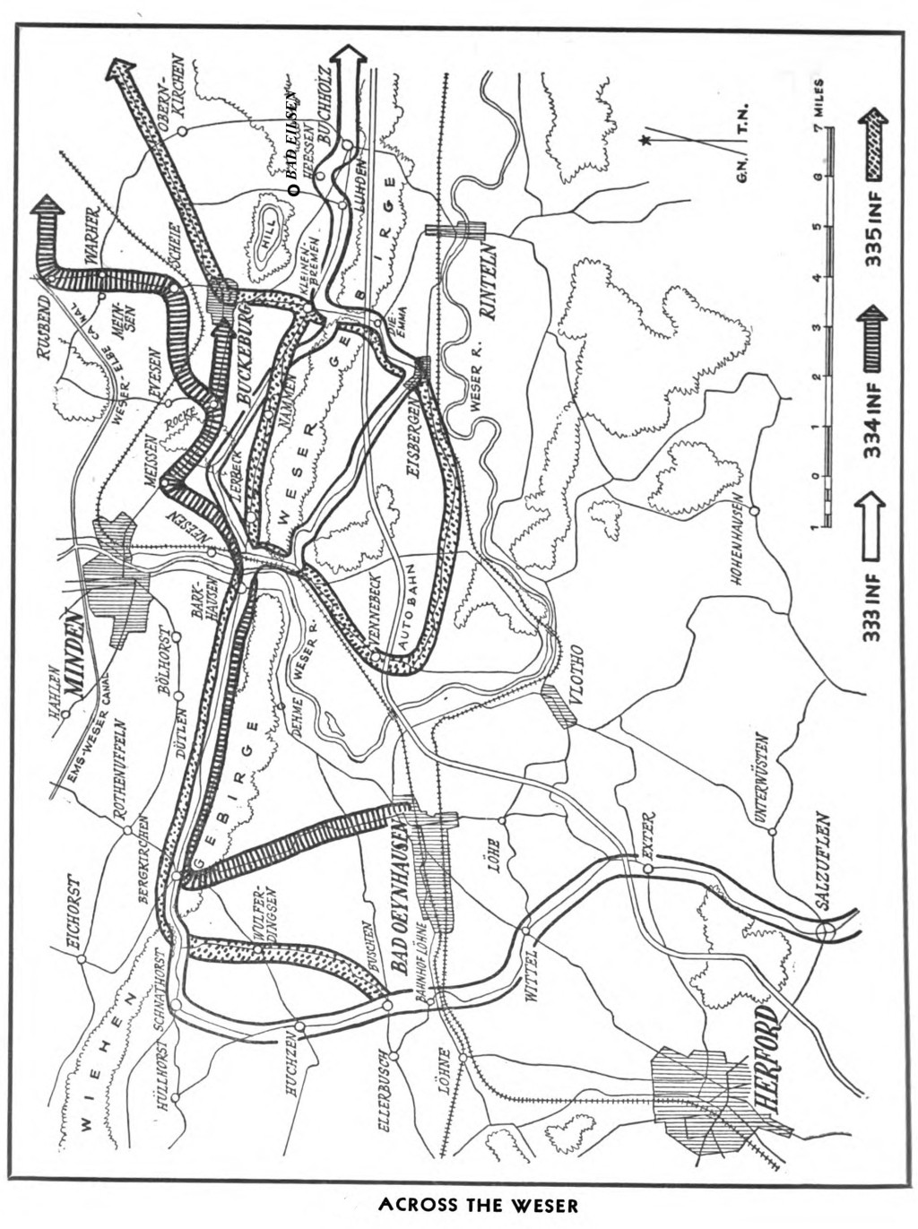

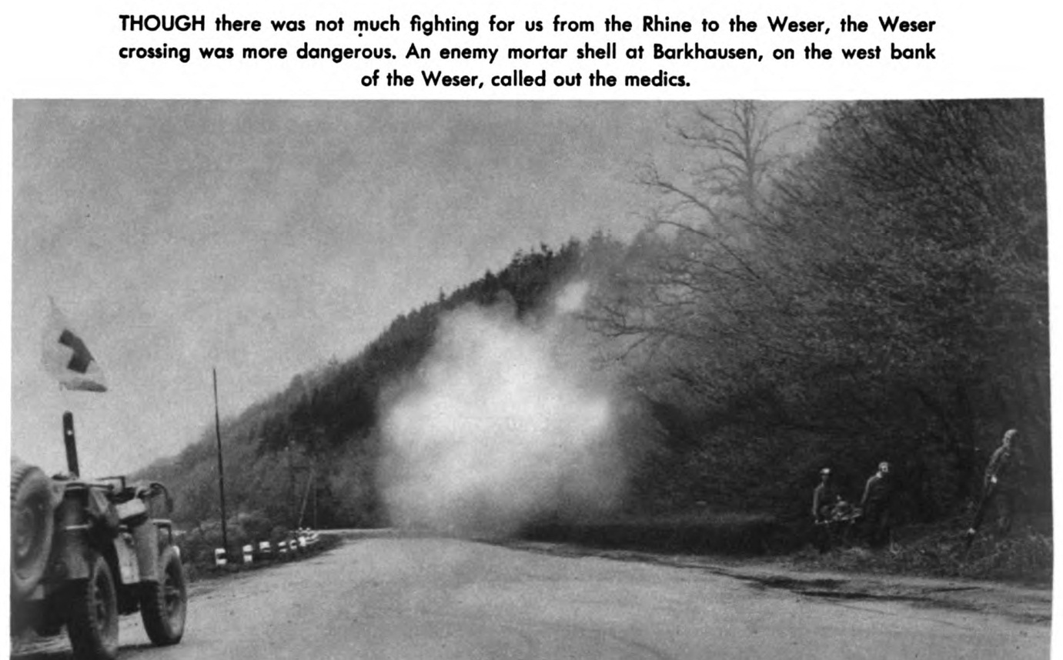

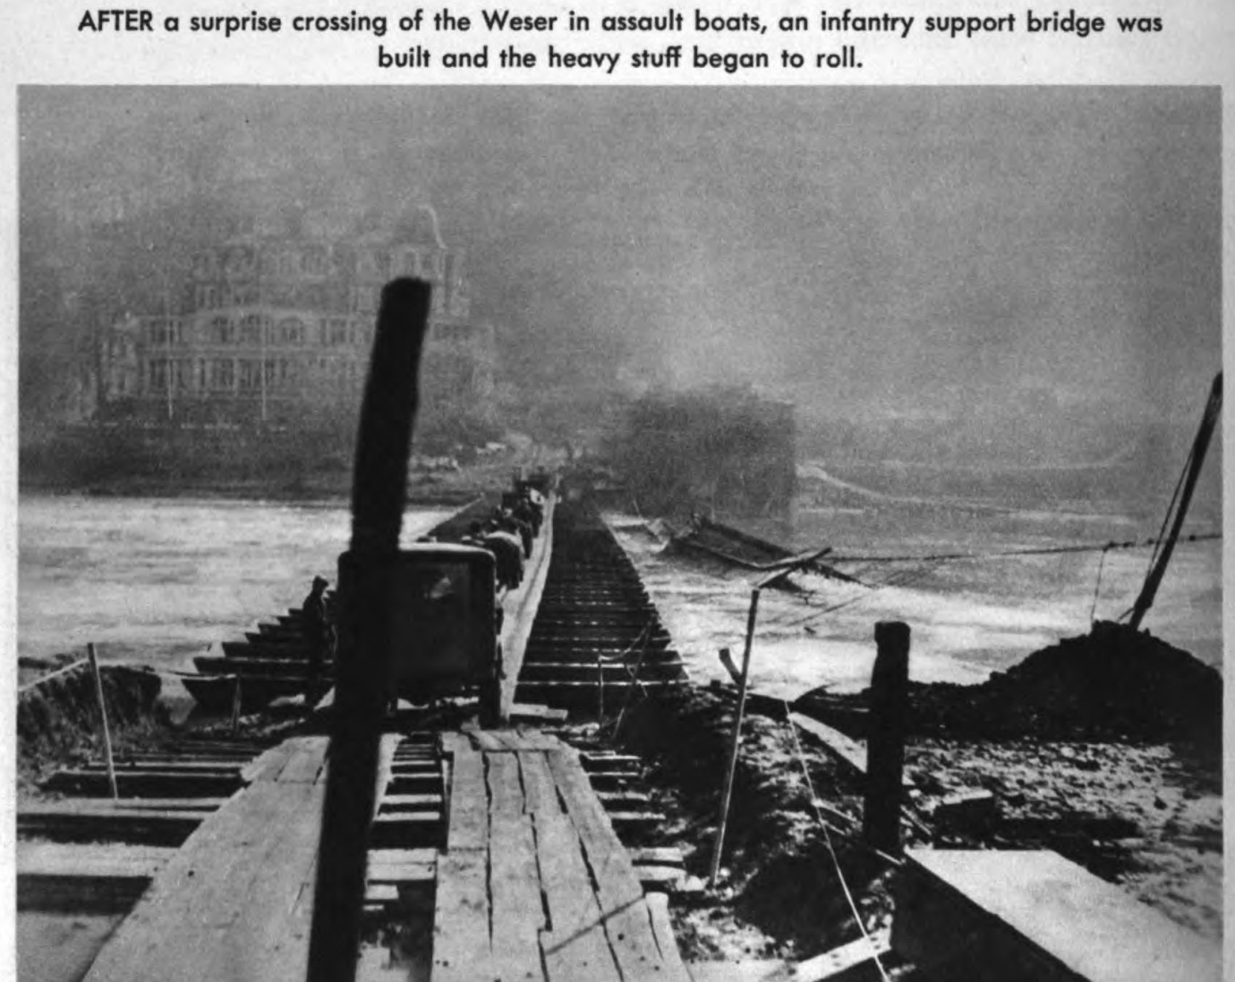
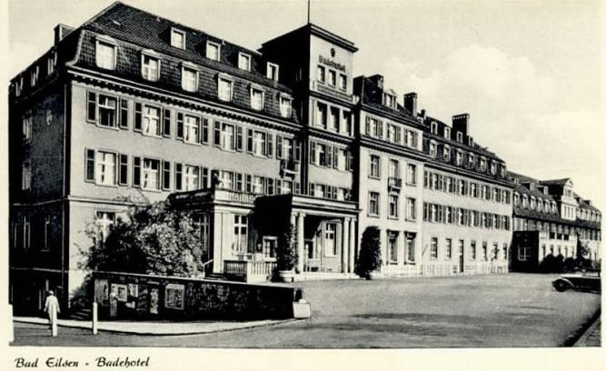
Pre-war (?) postcard. Site of Focke-Wulf headquarters.

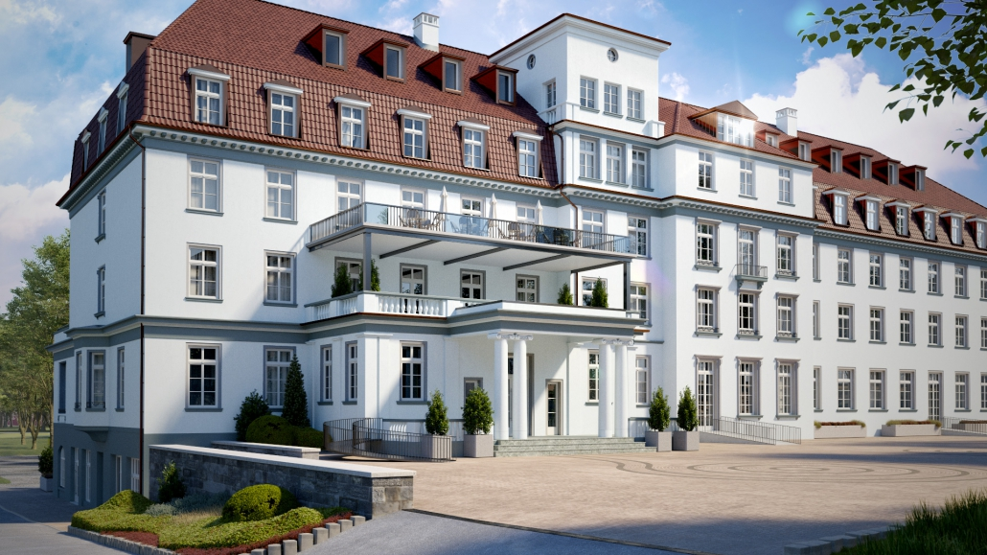
Nowadays. Recently converted to provide accommodation, with medical support, for the elderly: the Kurpark Residenz.

